**How to access the Virtual inspection room and your Inspector profile**

How you access the VIR has now changed and is different to your inspector profiles log in process.  You can access the inspection VIRs and your inspector profile on the Estyn website by clicking the link in the blue ribbon at the top of the website – [www.estyn.gov.uk](http://www.estyn.gov.uk)

* [Virtual Inspection Room](https://vir.cymru/)
* [Inspector Profiles](https://cygnum.estyn.gov.uk/live/ob.aspx/ist/)

Your username for the VIR will no longer need the word **Extranet** in front of the username but, you will now need to add **@vir.cymru** after the numbers.

For example:

**Username** – [02700@vir.cymru](mailto:02700@vir.cymru)

**Password** – Blue.Cathy82

User guides are available from the ‘Help’ section on the right-hand side of the home screen (outlined in red in the following screenshot) once you have logged in.

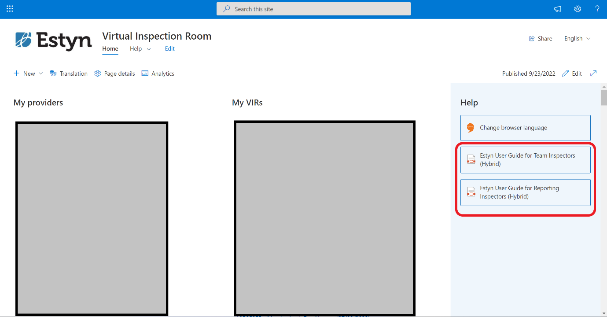

[This link](https://estynvws.sharepoint.com/:v:/s/VIRVids/EZ2qmbuYk9NJuvcX9hlO61IBXKGKRDUmS4pWV3xWmYurWQ?e=g1k0ST) will take you to a brief video explaining how to access the VIR.

**How to access your inspector profile**

The way in which you access your inspector profile remains unchanged. You will still need your username and password that you were given after your initial training.

For example:

**Username** - Extranet\02700

**Password** - Blue.Cathy82

If you would like to contact us about your inspector profile, VIR or have any queries about deployment please contact us – details are outlined below.