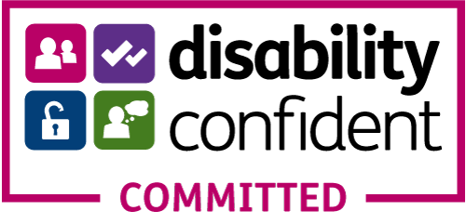
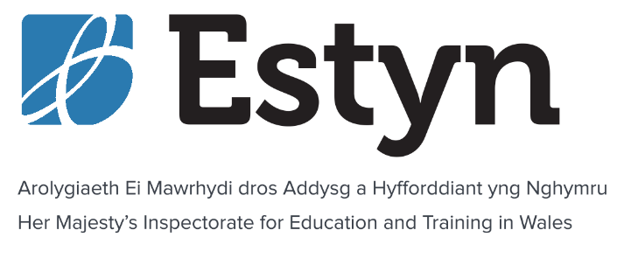

Her Majesty’s Inspector of Education and Training
(HMI)

Information Pack

A unique role in Welsh education

Closing date: 10am on Monday 14 February 2022

Contents

Welcome 4
A learning inspectorate: listening, learning and changing together 5
What we are looking for 7
What your role will involve 8
Additional information 9
What’s it like to be an HMI? 11
Why work for Estyn? 12
Equality and Diversity 12
Future opportunities 13
About us – Our work and our values 14
Benefits of joining Estyn 15
Apply now 17
Further Enquiries 17
Selection schedule 18

This document is available in Welsh on our website or from recriwtio@estyn.llyw.cymru

Welcome
A message from Owen Evans, Her Majesty’s Chief Inspector of Education and Training in Wales

It’s an exciting time to join Estyn. In this time of change in the Welsh education and training system, our priority is ensuring standards are excellent as we return our activities to a new normal. Over the next year we will:

- introduce our new inspection framework for schools and PRUs
- support schools to prepare for the new curriculum
- resume inspections in all our post-16 sectors
- play a leading role in the development of the Welsh education and training system in collaboration with our stakeholders
- support recovery from the challenges of Covid
I am proud to lead an organisation that has been recognised as playing a vital role in enhancing the learning of young people and adults in Wales. Learners are at the heart of everything we do. Our people are committed to working collaboratively to deliver a high quality service to our stakeholders that provides public accountability and supports improvement.

We are looking for the brightest and best leaders from all backgrounds to join us in achieving excellence for all learners in Wales. The role of a Her Majesty’s Inspector (HMI) is an exciting and varied one that gives you a privileged view of education and training in Wales. Working for Estyn could be an excellent development opportunity for you. Join us and you’ll be guaranteed every day is different in this rewarding role where you’ll play a vital role in making sure inspection is a positive experience for everyone involved.

We look forward to receiving your application.
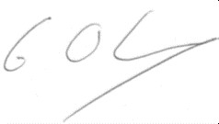

A learning inspectorate: listening, learning and changing together

The COVID-19 pandemic has changed peoples’ lives and posed major challenges to our education system.

Our work during the COVID-19 pandemic: In March 2020 we suspended inspections and paused our planned Learning Inspectorate programme. Since then we refocused our work on:

- supporting the education and training system to deliver continuity of learning
- informing the development of national policy
- contributing to the development of the Welsh education and training system
- engaging with almost all providers both virtually and in person to help support recovery, identify the challenges they’re facing and inform our plans across all sectors
- piloting new inspection arrangements for initial teacher education and remote inspections in the Welsh for Adults sector
- visiting work-based learning apprenticeship providers
- annual monitoring visits to independent schools that provide ALN provision
- continuing to support schools needing follow-up

Our HMI have accessed a wide range of professional learning including around the Curriculum for Wales, the Additional Learning Needs reforms and the role of the proposed new Commission for Tertiary Education and Research. All HMI have the opportunity to carry out a personal enquiry project to support our work.

Supporting renewal and reform: Moving forward, we will establish a framework of activity that aligns with the changes to education and training in Wales. We will balance the need to resume our inspection work with supporting recovery and will continue to be sensitive to the challenges facing education and training providers and their communities. We recognise that the context is ever-changing and we will need to retain flexibility in our delivery. We look forward to resuming the full breadth of our work and are committed to making inspections a positive experience for all.

We will:

- continue to support schools and PRUs to prepare for the new curriculum
- work with the Welsh Government and our stakeholders to support post-compulsory education and training reform and the national evaluation and improvement resource
- roll out pilot inspections for schools and PRUs after February half term
- restart joint inspections of non-maintained provision with Care Inspectorate Wales
- continue to monitor schools causing concern
- continue with our programme of engagement visits and thematic work and sharing insights of interesting practice
- continue with our plans for resuming inspections in other sectors
- roll out the second phase of piloting with all schools and PRUs in the summer term
- build on our excellent joint working and cooperation with inspectorates in Wales, the UK and further afield

2024 and beyond - Inspection will always bring a vital, independent perspective to assuring the quality and standards in schools and other providers. But as the changes in education and training in Wales evolve and schools mature in their approach to improvement, it is proposed that from 2024 more regular inspection will complement that national approach to evaluation and improvement. With the post-16 education and training reforms through the Tertiary Education and Research Bill and establishment of the Commission for Tertiary Education and Training, we will be evolving and developing our inspection arrangements with our post-16 stakeholders.

Want to know more? Visit: https://www.estyn.gov.wales/inspection/our-current-plans

What we are looking for

Our HMI come from a diverse range of leadership backgrounds in education and training. You may for example, be:

- the headteacher of a primary school or primary phase leader in an all-age school
- a senior leader in a secondary school or secondary phase leader in an all-age school
- a teacher-in-charge of a pupil referral unit
- a challenge advisor or principle challenge advisor
- a service area lead in an education directorate
- a quality manager or leader in a work-based learning provider
- a vice-principal or director of learning in a further education college
Whatever path your career has taken so far, you will have a strong track record of improvement with experience of innovating at a strategic level. You will also understand the wider education and training landscape and the role that inspection plays as a force for improvement.

For this recruitment we are looking for people with a background in:

- primary education
- secondary education
- local government education services
- post-16 education and training
For at least one of the primary and one of the secondary posts Welsh language skills are essential. For all other posts Welsh language skills are desirable.

Qualified teacher status (QTS) is an essential requirement for all posts except post-16 education and training.

The Full role specification provides further details about the role, the essential and desirable criteria and how these will be tested throughout the selection process.

What your role will involve

You will be responsible for reporting on the standards and quality of education and training in providers across Wales. You will contribute to the development and dissemination of effective practice and building capacity for improvement in the education and training system in Wales.

It’s a unique opportunity to experience and absorb practice in a large number and variety of providers and other educational settings; their ethos, character and approach to curriculum and innovation. Where providers are struggling, you will develop a keen insight into challenges and how improvements can be made.

Much of your work will be on-site in different settings, so you need to be willing to undertake significant travel across Wales and frequently stay overnight in hotels. Whenever possible, you will be allocated inspections close to home. Working from home between inspections, you will find a valuable work/life balance.

No two days will ever be the same. They could include anything from:

- talking to learners about their work
- visiting lessons
- talking to parents about their child’s education provider
- speaking with teachers and leaders
- In post-16, observing workshop activities and talking to employers, trainers and assessors
Acting as both a lead inspector and contributing to work across a range of sectors, you will develop a critical understanding of each provider, objectively reporting on standards and effectiveness. You will make judgements on the effectiveness of leadership in each provider, including how well learners are kept safe.

Putting the best interests of learners above all else, you will ensure that your judgements are fair and evidence-based. Sharing your evolving knowledge and expertise with colleagues, you will also prepare and deliver training for external Estyn Inspectors.

You will be a role model for our values, acting at all times in the interest of children and learners and promote and safeguard the welfare of children, young people and vulnerable adults you come into contact with.

Much of your work will see you directly interacting with providers, but the role will also require you to balance various additional challenges, like:
- contributing to national developments through the provision of professional advice and thematic work
- engaging with external stakeholders
- quality assurance of inspection reports and thematic work
- contributing to organisational development and change
We will give you all the support you need to excel in the role and develop new skills.

Additional information
Job Title: Her Majesty’s Inspector of Education and Training (HMI) (Grade 6)
Salary: £64,520 - £75,480 (full time equivalent). Please note, starting salary will normally be offered first scale point above your current salary (within this range), and will be pro rated based on your working hours.
Duration: Permanent
Welsh Language: We work in both Welsh and English and many of our stakeholders are bilingual. For at least one of the primary and one of the secondary posts Welsh language skills (verbal and written) are essential. For all other posts Welsh language skills are desirable.

Safeguarding - We are committed to safeguarding and promoting the welfare of children and young people and expect all our people to share this commitment. The role of HMI requires an enhanced disclosure check via the Disclosure and Barring Service (DBS). The role will bring you into direct contact with children or vulnerable adults and give you access to material or sensitive information about children and vulnerable adults. You will be expected to have an awareness of and the ability to comply with policies and procedures relating to:

- child protection
- health, safety and security
- confidentiality
- data protection

Orders in Council - If your application is successful, Orders in Council will need to be obtained from the Privy Council before you can be confirmed as an Her Majesty’s Inspector. You will be appointed as an HMI designate until Privy Council approval is obtained.
Location - We are based in Cardiff and our Inspectors are home-based. Our work is predominantly undertaken within Wales. On appointment, depending on the location of your home-base we may allocate you to a notional location for travel and subsistence and/or offer you financial assistance for relocation. You should check this before committing yourself to any expenses. If payment is made, it will be made after you have started work and you must agree to repay a proportion if you resign within a specified period. This role can only be worked in the UK and not overseas.
Driving licence and use of a car - Due to the requirement for frequent travel across Wales, you should have a current driving licence and the use of a car or the ability to make suitable alternative transport arrangements.

Work hours - Our normal work hours are 37 hours over a five day week (Monday to Friday), excluding lunch. This role requires frequent travel all over Wales and a regular need to be able to stay away from home for up to four nights.

Nationality - To be eligible for these roles you must meet the nationality requirements set out in the Guidance for Applicants.

What’s it like to be an HMI?

In the following film and profiles you’ll meet some of our current HMI who will share their experiences with you about what it’s like to be an HMI and the aspects of the role they find rewarding and challenging.
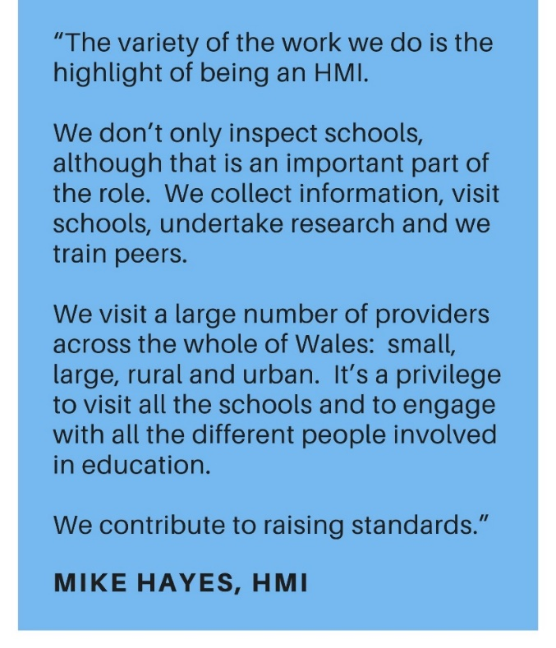
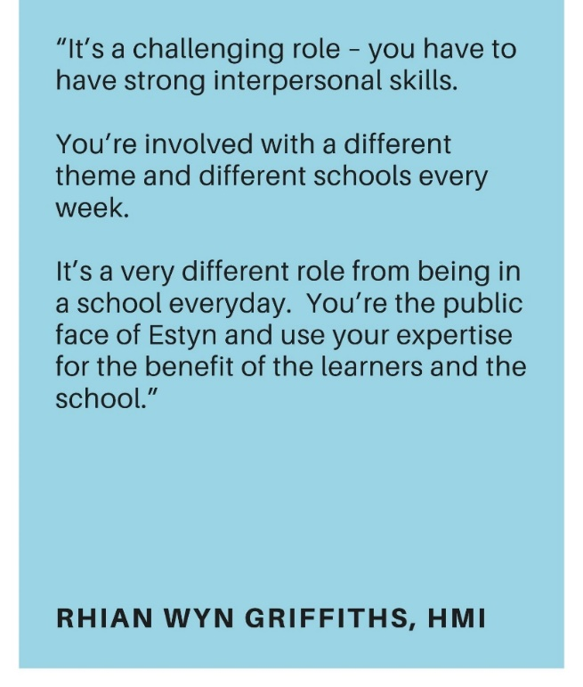
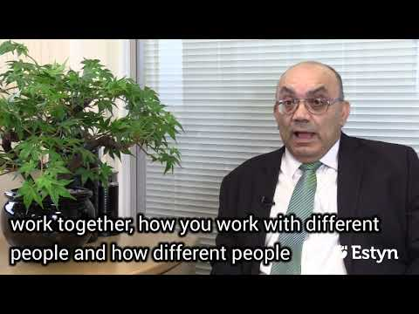
Click play on the videos to hear from a number of our HMI
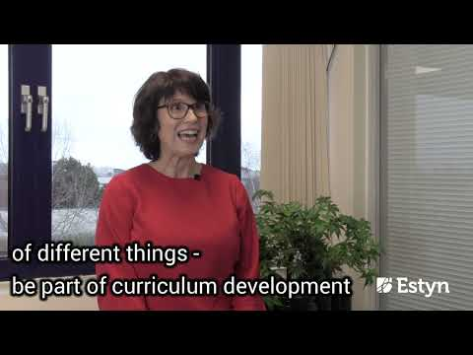
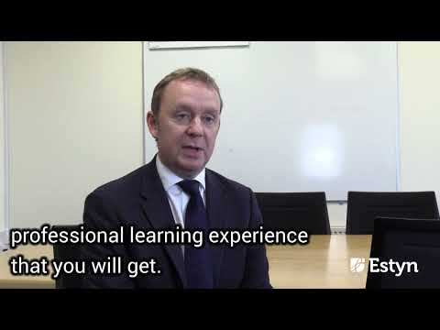

Why work for Estyn?

It’s a great place to work and our people are our most valuable resource. Our people are highly engaged in our work and our People Survey results are consistently among the best in the Civil Service. We’ve been awarded the Gold Standard from Investors in People (IiP).

We value, listen to, and encourage our people to develop their skills and talents. We enable our people to flourish and give their best. You’ll have access to learning and development opportunities that will help you develop valuable skills to help further your career. These include individual, team, professional and organisational learning, and continuous development.
Working from home in-between inspection and face-to-face meetings, you will benefit from the freedom and flexibility that comes with working independently, while supported by a broad network of colleagues who share your passion for education and learning. You may be required to work outside of normal hours, depending upon the provision or service being inspected.
Each HMI is allocated to a sector team and is supported by an Assistant Director and a peer mentor during your first year. After a comprehensive induction and learning period you will be in regular contact with colleagues within your sector and across other sectors, providing advice and support.

Equality and Diversity

We’re committed to supporting diversity and valuing individual differences. We recognise that everyone brings different skills and experience to our organisation, and that this diversity is what makes a strong organisation. We encourage applications from the widest possible diversity of backgrounds, cultures and experiences. We particularly welcome applications from people with an ethnic minority background, as well as people living with a disability.

Future opportunities

With ongoing training, you will develop valuable skills and have the opportunity to:

- become a sector lead inspector or lead officer for a specific area of work
- get involved in training external Estyn Inspectors
- contribute to the development of inspection arrangements and materials
- thematic research work and projects
- become an Assistant Director

About us – Our work and our values

We are Her Majesty’s Inspectorate for Education and Training in Wales. We inspect quality and standards in education providers around the country. Because of COVID-19 we’ve adapted the focus and delivery of all our work, but our mission, vision, strategic objectives and values have stayed the same.

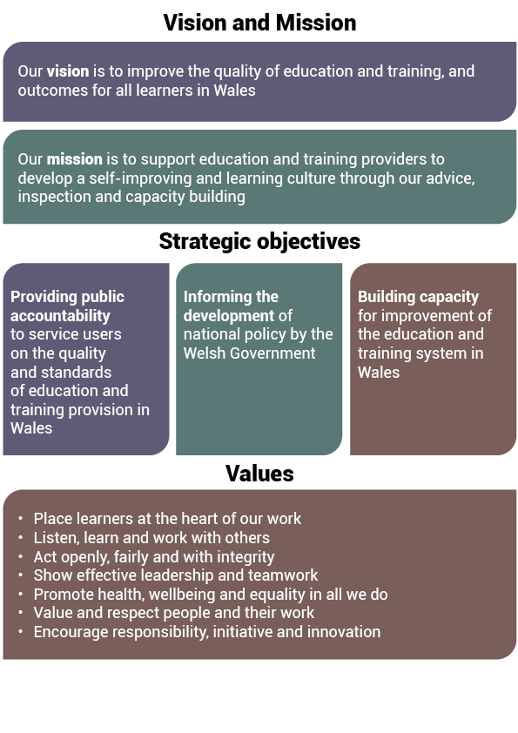

Our Annual Plan sets out our key activities for the year. Find out more about our work on our website: www.estyn.gov.wales/about-us.

As Civil Servants, we model the values, behaviours and standards set out in the Civil Service Leadership Statement and the Civil Service Code.
1 Our ‘leadership statement’ in our Annual Plan sets out the expected behaviours and the approach to leadership that we expect from all our staff.
2 The Civil Service Code sets out the Civil Service values, standards of behaviour, and rights and responsibilities.

Benefits of joining Estyn

In addition to a good work/life balance, job satisfaction, a supporting culture, ongoing learning and development opportunities and professional development, you can also expect other benefits, including the following:

Competitive salary - The full time equivalent salary range is £64,520 - £75,480. Starting salary will normally be the first scale point above your current salary (within this range). Visit our website for the full Grade 6 pay scale. With incremental progression you will normally reach the maximum of the pay scale within three years of joining
Paid travel and expenses – Central booking service for travel and overnight stays (paid directly by Estyn). Mileage and car-parking fees reimbursed. Meal and refreshments allowance for overnight stays
Excellent pension – Choose from a defined benefit pension scheme with Estyn contributing up to 27.9% of your salary or a defined contribution arrangement. We are part of the Civil Service Pension Scheme. If you’re already in a Pension Scheme you can freeze this or transfer it into the Civil Service Pension Scheme
Generous holiday entitlement – 31 days of annual leave, plus 10 public/privilege holidays each year. Annual leave is pro-rated for those who work part-time. Further paid / unpaid leave options available to help combine work with other life commitments and responsibilities (e.g. career break, compassionate leave, fostering to adopt etc) subject to business needs
Support for your wellbeing – We provide a 24/7 employee assistance programme including access to emotional support counselling and specialist advisors, free annual health check, trained mental health first aiders, a free eye care scheme and subsidised flu jabs. We’ve achieved the Silver Award for the Corporate Health Standard for our health and wellbeing support. We also provide access to Health Insurance Plans through Civil Service Healthcare
Diversity and inclusion – We want to maximise the potential of everyone who works for us, regardless of their background. We’ve created a working environment that is welcoming, respectful, and engaging for everyone, with opportunities for personal and professional development
Support for your family life – generous maternity, paternity, adoption, shared parental and parental leave and flexible working
Tax-free savings – Access to a cycle to work scheme and a green car salary sacrifice scheme
Modern equipment – home office facilities, such as a laptop, printer, mobile phone. We will also provide you with a desk, chair and filing cabinet
Additional financial support – including interest-free salary advance for travel season tickets and a working from home allowance of £450 a year
Special offers and discounts – Access to a range of discounts and exclusive offers for many high street shops, cinemas, supermarkets, holidays, restaurants, gyms and family attractions through the Civil Service Social Club – Sports and Leisure. Access to further benefits and services including the Civil Service Motoring Association, the Civil Service Insurance Society and the Charity for Civil Servants

For more information about the benefits available visit our website: www.estyn.gov.wales/WorkingforEstyn

Apply now

Application form

Download and complete our application form here: www.estyn.gov.wales/working-us/current-vacancies

Guidance

Our Applicant Guidance provides useful information about the selection process and tips to help you with your application.

These documents are also available in Welsh and English from www.estyn.gov.wales/working-us/current-vacancies

Closing date: 10am on Monday, 14 February 2022

We won’t consider any applications we receive after this time and date, or any incomplete applications.

Send your completed application to: recruitment@estyn.gov.wales

We recommend emailing your application. We are currently experiencing delays in receiving post that may mean your application is late. If you’re unable to send your application electronically, please contact Shuna Lovering on 029 2044 6336.

This recruitment exercise is conducted in accordance with the Civil Service Commission Recruitment Principles and is regulated by the Civil Service Commission.

Alternative or accessible documents: If you’d like to apply or access this document in an alternative format, please contact Shuna Lovering to discuss your requirements.

Further Enquiries

If you have any questions about this recruitment exercise that we haven’t answered in this pack, please contact Shuna Lovering on 029 2044 6336, or recruitment@estyn.gov.wales

We welcome correspondence in Welsh; we’ll respond to you in Welsh, and there won’t be a delay in our response.

Selection schedule

*Dates may be subject to change

