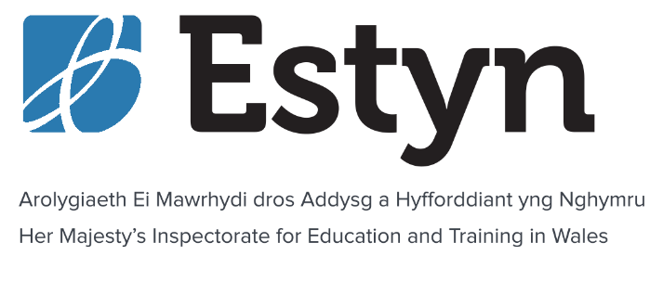

Additional Inspector (AI) Secondment

Secondary Sector

**Information for Applicants**

*A unique role in Welsh education*

**Closing date: 19 May 2021**

C:\Users\bethan.rees\AppData\Local\Microsoft\Windows\INetCache\Content.Outlook\SQ8KKD0D\CSC-kitemark_2010_CMYK_5x5cm_300dpi (002).tif 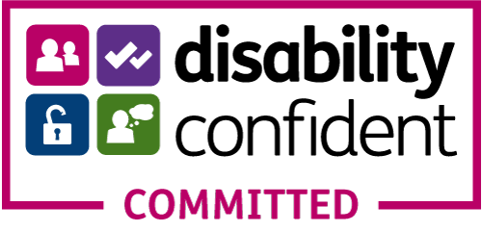

# 

Contents

[Welcome 3](#_Toc70609921)

[About us 4](#_Toc70609922)

[A learning inspectorate: listening, learning and changing together 6](#_Toc70609923)

[What we are looking for 7](#_Toc70609924)

[What your role will entail 8](#_Toc70609925)

[Additional requirements of the role 9](#_Toc70609926)

[Welsh Language 9](#_Toc70609927)

[Secondment details 10](#_Toc70609928)

[What’s it like to be an HMI? 11](#_Toc70609929)

[Being part of Estyn 12](#_Toc70609930)

[Future opportunities 12](#_Toc70609931)

[Benefits of joining Estyn 13](#_Toc70609932)

[Apply now 14](#_Toc70609933)

[Further Enquiries 14](#_Toc70609934)

[Selection schedule 15](#_Toc70609935)

**This document is available in Welsh on our** [**website**](https://www.estyn.llyw.cymru/gweithio-ni/gweithio-i-ni?_ga=2.174547106.1400315559.1613463765-378890110.1613463765) **or from** [**recriwtio@estyn.llyw.cymru**](mailto:recriwtio@estyn.llyw.cymru)

# Welcome

|  |  |
| --- | --- |
| cid:image001.jpg@01D57768.8F3A89A0 | **A message from Meilyr Rowlands, Her Majesty’s Chief Inspector of Education and Training in Wales**  Thank you for your interest in joining Estyn. In this time of crisis with the COVID-19 pandemic, our work continues with a focus on providing independent, objective evidence and advice. We continue to inform the development of national policy and support the education and training system to deliver learning forward. Our work, in collaboration with our stakeholders, will contribute to the development of the Welsh education system during these unprecedented times. We will resume our routine work and the delivery of our planned [Learning Inspectorate](https://www.estyn.gov.wales/node/13695) programme (supporting schools to prepare for the new curriculum and introducing new inspection arrangements) as soon as it is safe and practical to do so.  I am proud to lead an organisation that has been recognised as playing a vital role in enhancing the learning of young people in Wales. Our people are committed to working collaboratively to deliver a high quality service to our stakeholders that provides public accountability and supports improvement.  The role of an Additional Inspector (AI), working alongside our Her Majesty’s Inspectors (HMI) is an exciting and varied one that gives you a privileged view of education and training in Wales.  Working for Estyn could be an excellent development opportunity for you. We are currently looking for an AI who is able to work effectively through the medium of Welsh to support us in achieving excellence for all learners in Wales, with secondary sector expertise.  cid:image002.jpg@01D57768.8F3A89A0We look forward to receiving your application. |

# About us

Estyn is Her Majesty’s Inspectorate for Education and Training in Wales.

Our mission is to achieve excellence for all learners in Wales. We do this by providing an independent, high-quality inspection and advice service to the Welsh Government and the citizens of Wales.

We are independent of, but funded by, the Welsh Government (section 104 of the Government of Wales Act 1998).

Our inspections and advice work are carried out by Her Majesty’s Inspectors (HMI) and supported by our Corporate Services colleagues. Corporate Services work together and with our inspectors to deliver agile services to help us achieve our strategic objectives.

We:

* Inspect providers of education and training
* Provide advice and guidance
* Build capacity and spread best practice
* Work in partnership with other inspectorates, education bodies and stakeholders

Further information about our work can be found on our website: [www.estyn.gov.wales/about-us](https://www.estyn.gov.wales/about-us).

Each year we publish an [Annual Plan](https://www.estyn.gov.wales/publications-and-policies/corporate-publications) that sets out the key activities for the year that support the delivery of our mission, strategic objectives and reflects our delivery principles. The COVID-19 situation has required us to adapt the focus and delivery of our work, but our mission, vision and strategic objectives remain unchanged. Further details can be found below.

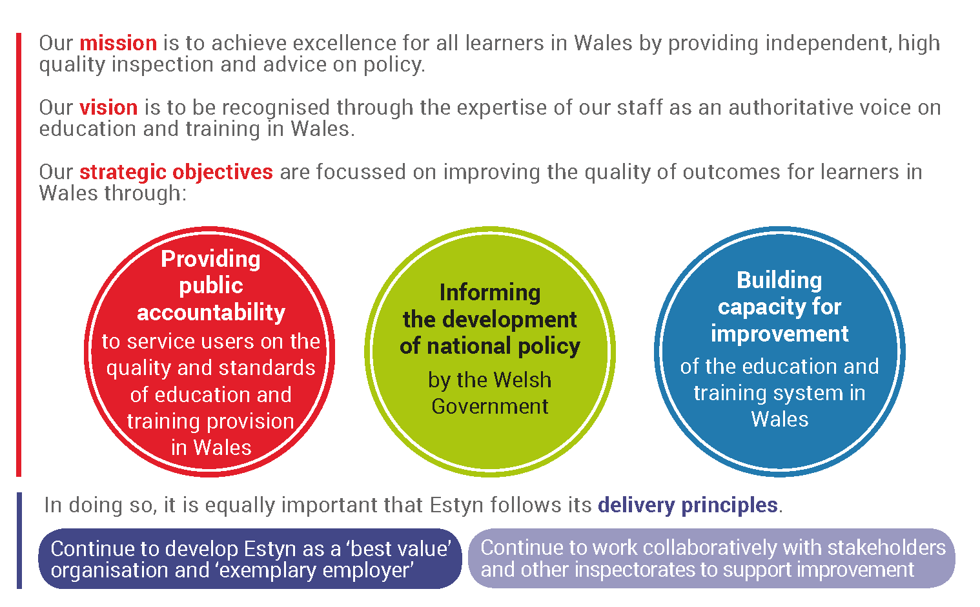

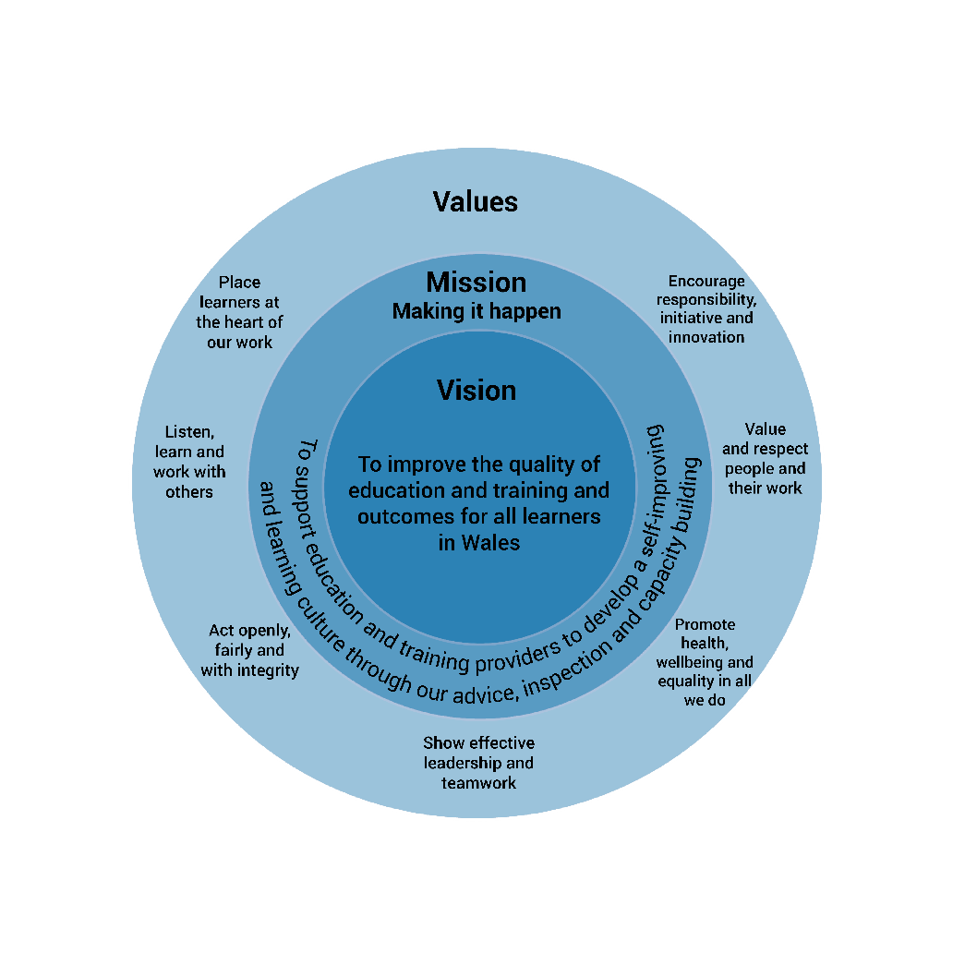

The [Civil Service Leadership Statement](https://assets.publishing.service.gov.uk/government/uploads/system/uploads/attachment_data/file/405453/CS_leadership_statement_3__1_.pdf) sets out the expected behaviours and the approach to leadership that we expect from all our staff. The [Civil Service Code](https://www.gov.uk/government/publications/civil-service-code/the-civil-service-code) sets out the Civil Service values, standards of behaviour and rights and responsibilities. As Civil Servants, all our people are expected to observe the principles of the Civil Service Code.



1 Our ‘leadership statement’ in our [Annual Plan](https://www.estyn.gov.wales/about-us/corporate-publications-accounts) sets out the expected behaviours and the approach to leadership that we expect from all our staff.

2 The [Civil Service Code](https://www.gov.uk/government/publications/civil-service-code/the-civil-service-code) sets out the Civil Service values, standards of behaviour, and rights and responsibilities.

# A learning inspectorate: listening, learning and changing together

The COVID-19 pandemic has changed peoples’ lives and posed major challenges to our education system. Before the pandemic, education was already changing in Wales. Estyn and inspection are changing too with three phases of change between 2020 and 2024:

**Phase 1: 2020-2021 Transition year** – Our original plans for the transition year were disrupted by the COVID-19 pandemic. In March 2020 we suspended all inspections and paused our planned Learning Inspectorate programme. We refocused our work on:

* informing the development of national policy
* supporting the education and training system to deliver continuity of learning
* contributing to the development of the Welsh education system

We continue to engage with schools, conducting remote engagement activities initially. Our engagement activities focus on the response to the impact of the pandemic and identifying the challenges schools are facing. Our programme for inspecting other non-school sectors has also been replaced by remote engagement activities to help support the recovery from the pandemic. We continue to support schools needing follow-up and tailor our approach to their individual circumstances.

At an appropriate point, our focus for these engagement visits will shift back to how schools are preparing for curriculum reform. We will work with our stakeholders across sectors to decide how we will engage with them and at what point we will resume our routine inspection and monitoring work.

**Phase 2: September 2021 A new inspection framework** – When school inspections resume we will introduce new inspection arrangements to align with the changes to education in Wales.

**Phase 3: 2021-2024 Pilot inspections** - We will be piloting inspections that focus on validating schools’ self-improvement processes.

**2024 and beyond** -Inspection will always bring a vital, independent perspective to assuring the quality and standards in schools. But as the changes in education evolve and schools mature in their approach to improvement, it is proposed that from 2024 inspection will have a stronger focus on validating the school’s own view of their standards. Inspectors will report on how confident they are that the school’s self-evaluation process is accurate and robust. We will then roll out shorter, more regular validation inspections when schools are ready.

Want to know more? Visit: [www.estyn.gov.wales/learning-inspectorate](https://www.estyn.gov.wales/learning-inspectorate)

# What we are looking for

Our Inspectors come from a diverse range of leadership backgrounds in education. You may for example, be the secondary phase leader in an all-age school or headteacher in a secondary school. Whatever path your career has taken so far, you will have a strong track record of improvement with experience of innovating at a strategic level. You will also understand the wider education landscape and the role that inspection plays as a force for improvement.

For this recruitment we are looking for people with a background in secondary education.

**Welsh language skills** are **essential** for this post.

**Qualified teacher status (QTS)** is an **essential** requirement for this post.

The [**Full role specification**](https://www.estyn.gov.wales/working-us/current-vacancies#currentvacancies)provides further details about the role, the essential and desirable criteria and how these will be tested throughout the selection process.

# What your role will entail

You will be responsible for reporting on the standards and quality of education and training in providers across Wales. You will contribute to the development and dissemination of effective practice and building capacity for improvement in the education and training system in Wales. It’s a unique opportunity to experience and absorb practice in a large number and variety of schools and other educational settings; their ethos, character and approach to curriculum and innovation. Where providers are struggling, you will develop a keen insight into challenges and how improvements can be made.

When we resume visits to providers, much of your work will be on-site in different settings, so you need to be willing to undertake significant travel across Wales and stay overnight frequently in hotels. Whenever possible, you will be allocated inspections close to home. Working from home between inspections, you will find a valuable work/life balance.

No two days will ever be the same. They could include anything from talking to pupils and students about their work, visiting lessons, talking to parents about their child’s education provider, and speaking with teachers and leaders. Acting as both a lead inspector and contributing to work across a range of sectors, you will develop a critical understanding of each provider, objectively reporting on standards and effectiveness. You will make judgements on the effectiveness of leadership in each provider, including how well students are kept safe.

Putting the best interests of learners above all else, you will ensure that your judgements are fair and evidence-based. Sharing your evolving knowledge and expertise with colleagues, you will also prepare and deliver training for external Estyn Inspectors.

You will be a role model for Estyn’s values, acting at all times in the interest of children and students and promote and safeguard the welfare of children and young people you come into contact with.

Much of your work will see you directly interacting with providers, but the role will also require you to balance various additional challenges, like contributing to national developments through the provision of professional advice and thematic work, engaging with external stakeholders, quality assurance of inspection reports and thematic work and contributing to organisational development and change. We will give you all the support you need to excel in the role and develop new skills.

# Additional requirements of the role

**Safeguarding -** We are committed to safeguarding and promoting the welfare of children and young people and expect all our people to share this commitment. The role of HMI requires an enhanced disclosure check via the Disclosure and Barring Service (DBS). The role will bring you into direct contact with children or vulnerable adults and give you access to material or sensitive information about children and vulnerable adults. You will be expected to have an awareness of and the ability to comply with policies and procedures relating to child protection, health, safety and security, confidentiality and data protection.

**Location -** We are based in Cardiff and our Inspectors are home-based. Our work is predominantly undertaken within Wales, on appointment depending on the location of your home-base we may allocate you to a notional location for travel and subsistence.

**Driving licence and use of a car -** Due to the requirement for frequent travel, you should have a current driving licence and the use of a car.

**Work hours -** Our normal work hours are 37 hours over a five day week (Monday to Friday), excluding lunch.

**Nationality –** To be eligible for these roles you must meet the nationality requirements set out in the [Guidance for Applicants](https://www.estyn.gov.wales/working-us/current-vacancies?_ga=2.10216181.1705140105.1612862263-1615018.1612862263).

# Welsh Language

Estyn conducts its business in both Welsh and English and many of our stakeholders are bilingual.

For these posts Welsh language skills are **essential**.

# Secondment details

**Duration:** The duration of this role is likely to be one year starting in September 2021.

**Salary:** The salary will normally be in line with your current salary. You will continue your existing pension arrangements with your current employer. We will reimburse the employer’s pension contributions for the duration of the secondment, as well as salary and other on-costs including national insurance as you will continue to be paid by your employer.

**Eligibility:** To be considered for a secondment you must be employed and be able to return to your substantive (or another post) with your current employer at the end of the secondment. If you are interested in applying for the secondment opportunity, you should discuss this with your current employer and obtain their agreement in principle to release you.

**Terms and conditions:** You will retain the terms and conditions of your existing employer, with the exception of hours of work and annual leave. Your annual leave entitlement will be discussed with you before you join and will depend on your current circumstances.

# What’s it like to be an HMI?

In the following film and profiles you’ll meet some of our current HMI who will share their experiences with you about what it’s like to be an HMI and the aspects of the role they find rewarding and challenging.

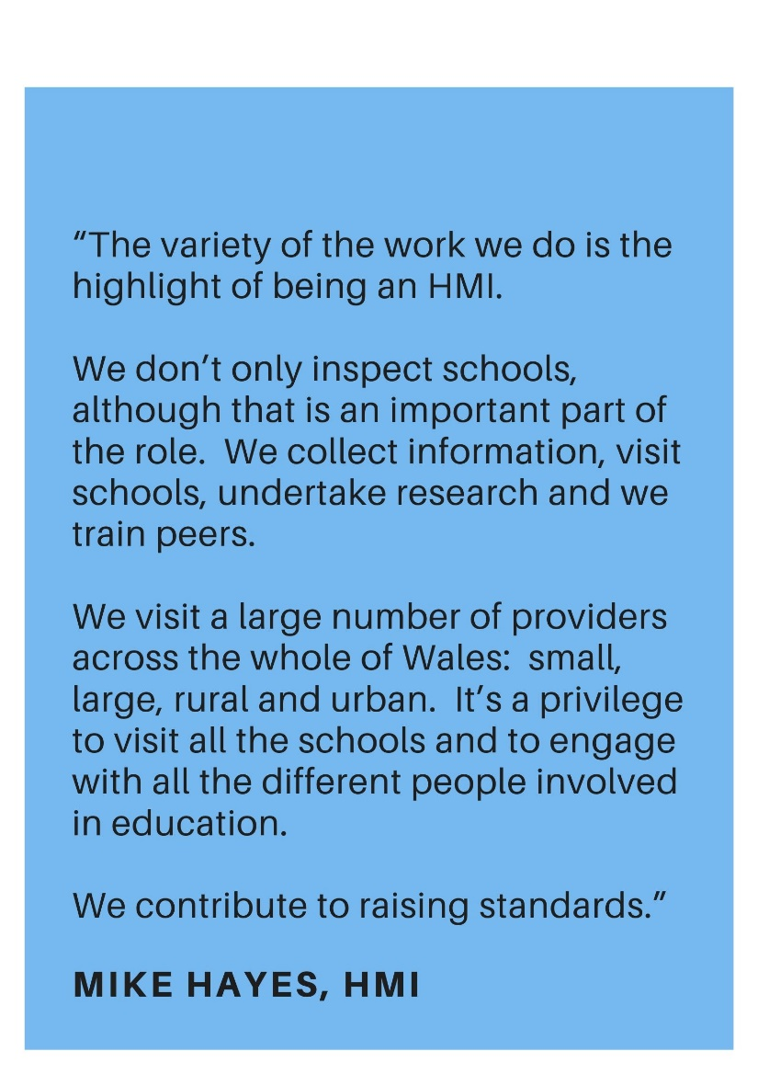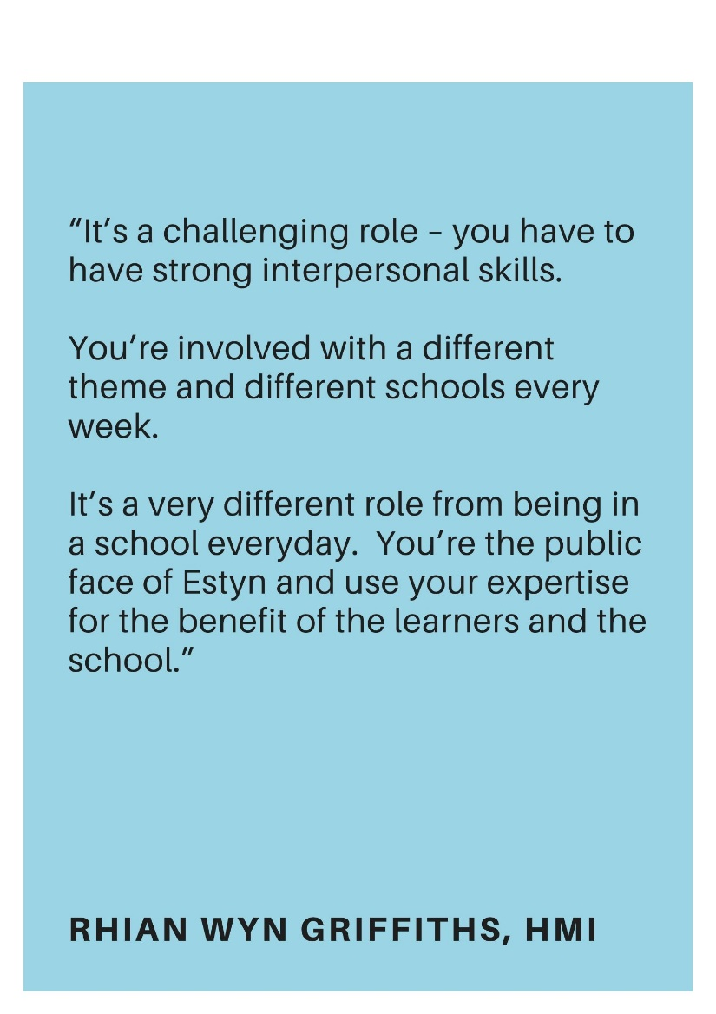

Click play on the video to hear from a number of HMI

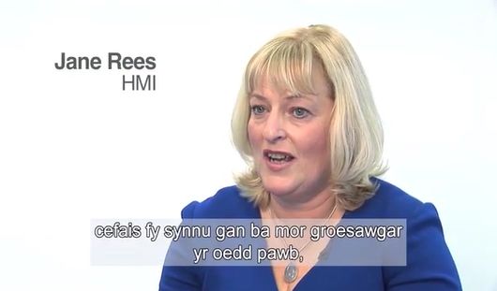

# Being part of Estyn

Our people are our most valuable resource. Our people are highly engaged in our work and we are consistently ranked among the top Civil Service organisations for engagement (based on the Civil Service People Survey). Our investment in our people has been recognised through the Gold Standard award from Investors in People (IiP).

We engage our people by valuing, listening to, and encouraging them to develop their skills and talents. We enable our people to flourish and give their best through individual, team, professional and organisational learning, and continuous development. We support and welcome diversity and value individual differences, recognising that each person brings different skills and experience to our organisation.

Working from home in-between inspection and face-to-face meetings, you will benefit from the freedom and flexibility that comes with working independently, while supported by a broad network of colleagues who share your passion for education and learning. You may be required to work outside of normal hours, depending upon the provision or service being inspected.

Each Additional Inspector is allocated to a sector team and is supported by an Assistant Director and peer mentor. After a comprehensive induction and learning period you will be in regular contact with colleagues within your sector and across other sectors, providing advice and support.

# Future opportunities

With ongoing training, you will develop valuable skills which will be helpful in any quality improvement role you may have within your current employment. Where there are any future vacancies for the role of HMI, your experience on secondment will give you a good idea of the range of work of an HMI if you consider applying.

# Benefits of joining Estyn

In addition to a good work/life balance, job satisfaction, a supporting culture, ongoing learning and development opportunities and professional development, you can also expect other benefits, including the following:

|  |  |
| --- | --- |
|  | **Paid travel and expenses** – Central booking service for travel and overnight stays (paid directly by Estyn). Mileage and car-parking fees reimbursed. Meal and refreshments allowance for overnight stays |
|  | **Generous holiday entitlement** – you can choose to retain your existing holiday entitlement with your current employer or accept our annual leave entitlement of 31 days of annual leave, plus 10 public/privilege holidays each year. Annual leave is pro-rated for those who work part-time. |
|  | **Support for your wellbeing** – Wellbeing support, a 24/7 employee assistance programme including access to emotional support counselling and specialist advisors, free annual health check, trained mental health first aiders, free eye care scheme and subsidised flu jabs. Our support for the health and wellbeing of our people has been recognised through the achievement of the Silver Award for the Corporate Health Standard. Access to Health Insurance Plans through Civil Service Healthcare |
|
|  | **Diversity and inclusion** – We want to maximise the potential of everyone who chooses to work for us – regardless of background. Our commitment to diversity, equality and inclusion means creating a work environment for all that is welcoming, respectful, engaging and enriched with opportunities for personal and professional development |
|  | **Modern equipment** – home office facilities, such as a laptop, printer, mobile phone. We will also provide you with a desk, chair and filing cabinet |

For more information about the benefits available visit our website: [www.estyn.gov.wales/WorkingforEstyn](https://www.estyn.gov.wales/system/files/2020-07/Working%2520for%2520Estyn%2520-%2520FINAL%2520OCT%25202018%2520v2%2520-%2520EN.pdf)

# Apply now

**Application form**

Download and complete our application form here: [www.estyn.gov.wales/working-us/current-vacancies](https://www.estyn.gov.wales/working-us/current-vacancies)

**Guidance**

Our Applicant Guidance provides useful information about the selection process and tips to help you with your application.

These documents are also available in Welsh and English from [www.estyn.gov.wales/working-us/current-vacancies](http://www.estyn.gov.wales/working-us/current-vacancies)

**Closing date: 10 am** on **Wednesday, 19 May 2021**

Applications received after this time and date, or incomplete applications, will not be considered.

Send your application to: [**recruitment@estyn.gov.wales**](mailto:recruitment@estyn.gov.wales)

We encourage an electronic application due to COVID-19. Due to office closure there are delays in receiving post that may impact on receipt of your application. If you are unable to send your application electronically please contact us using the details below to discuss further.

**Alternative formats**

If you require this document in an alternative format or would like to apply for this role in an alternative format please contact us to discuss your requirements.

# Further Enquiries

For enquiries about this recruitment exercise please contact Shuna Lovering on 029 2044 6307, or [recruitment@estyn.gov.wales](mailto:recruitment@estyn.gov.wales). We welcome correspondence in Welsh, will respond to correspondence in Welsh, and corresponding in Welsh will not lead to delay.

# Selection schedule

\*Dates may be subject to change